Electromagnetic induction
1. Faraday’s law
(1) electromotive force (emf)
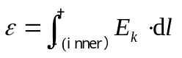
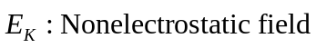
Scalar，direction: from the negative pole to the positive pole
(2) Lenz’s law
Induced current always flows to create a magnetic field that opposes the change in flux through the circuit.
(3) Faraday’s law
The induced emf in a loop is equal to the negative of the time rate of change of magnetic flux through the loop.
2. induced emf
(1) Motional electromotive force
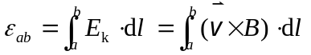
direction：（1）Lenz’s law （assume a circuit ）
（2）along 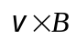
(2) Emf induced by changing magnetic fields
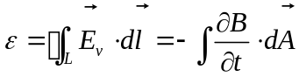 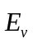： induced field
direction：：（1）Lenz’s law （assume a circuit ）
（2）Faraday’s law

3. Self inductance and mutual inductance
(1) Self inductance
(a) Self inductance
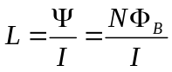
(b) emf of self inductance
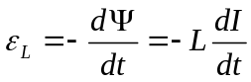
The self inductance L depends only on the geometry (size, shape, turns ) and on the presence of a ferromagnetic material
(2) mutual inductance
(a) mutual inductance
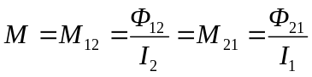
(b) emf of mutual inductance

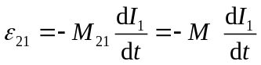 ， 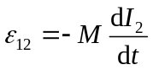
The mutual inductance M depends only on the geometric factors (size, shape, turns, and relative positions) and on the presence of a ferromagnetic material.
4. Energy stored in a magnetic field
(1) magnetic energy in terms of self-inductance
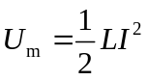
(2) magnetic energy in terms of magnetic energy density
Magnetic energy density
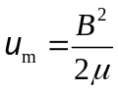
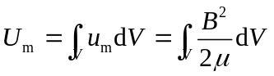

5. Maxwell 's Equations
(1) displacement current
(a) displacement current
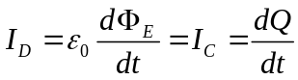
(b) general form of a current
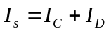 Current is continuous
(c) Ampère ’s law (with displacement current)
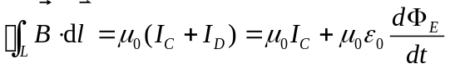
A changing electric field produces a displacement current, and it is equivalent to an ordinary electric current.
(2) Maxwell 's Equations
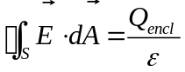
The electric flux through any closed surface is equal to the net charge enclosed by the surface divided by permittivity of free space
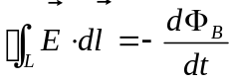
A changing magnetic field produce a electric field.
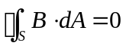
The net magnetic flux through any closed surface is equal to zero.
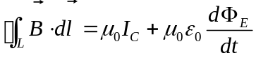
A changing electric field produce a magnetic field

